Welcome to
Early Years
at St John’s Primary School

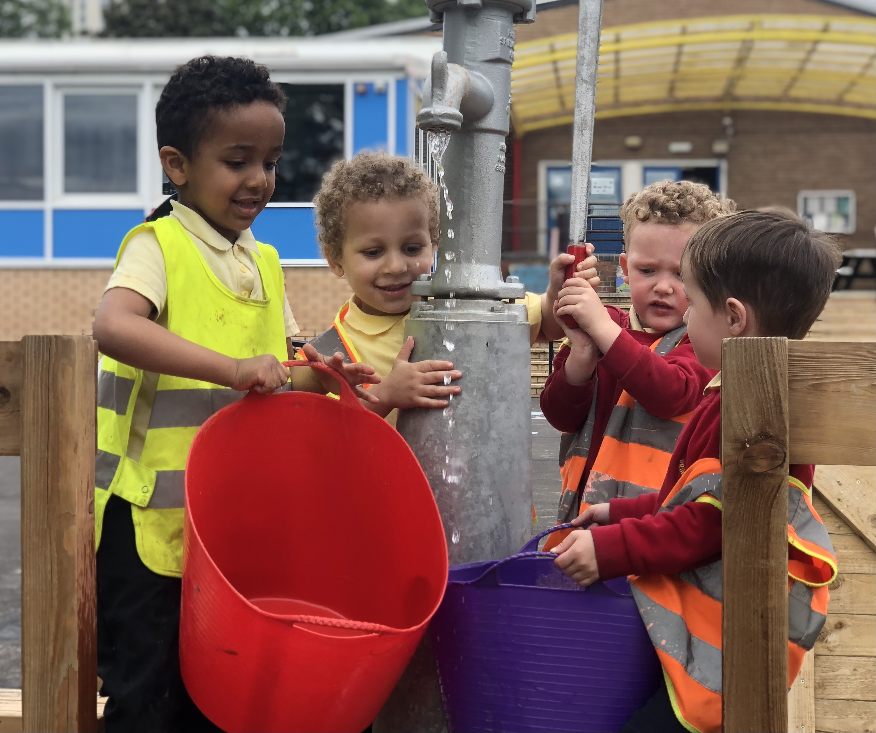
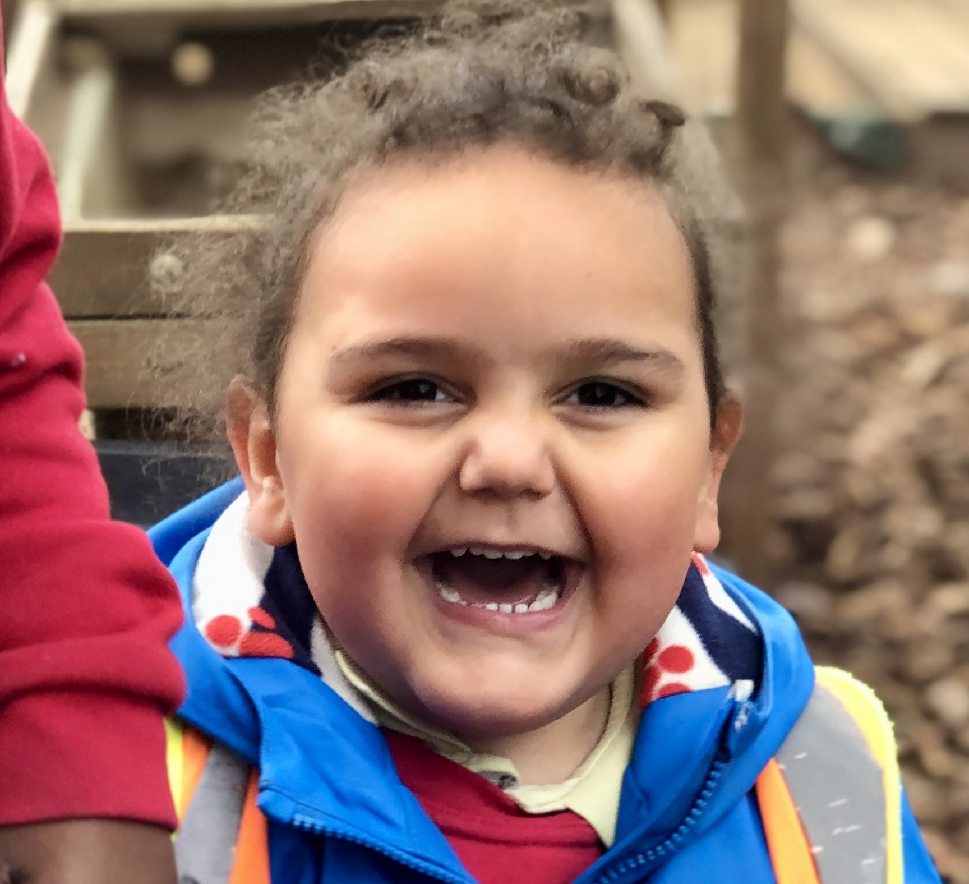
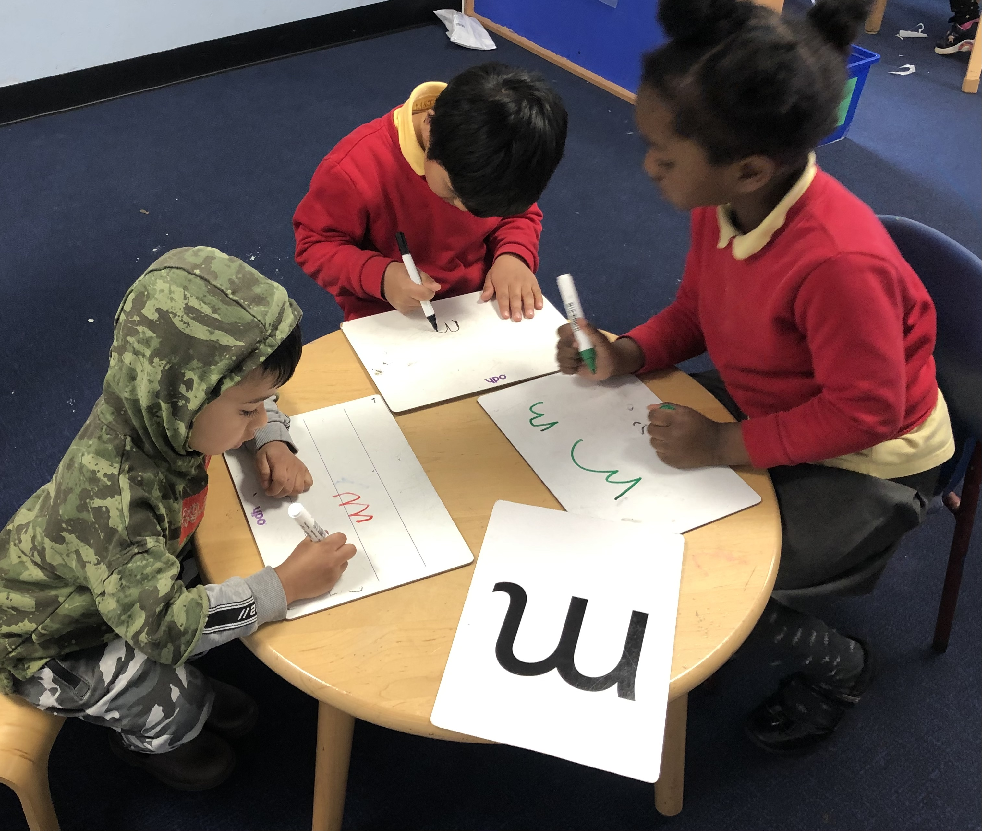

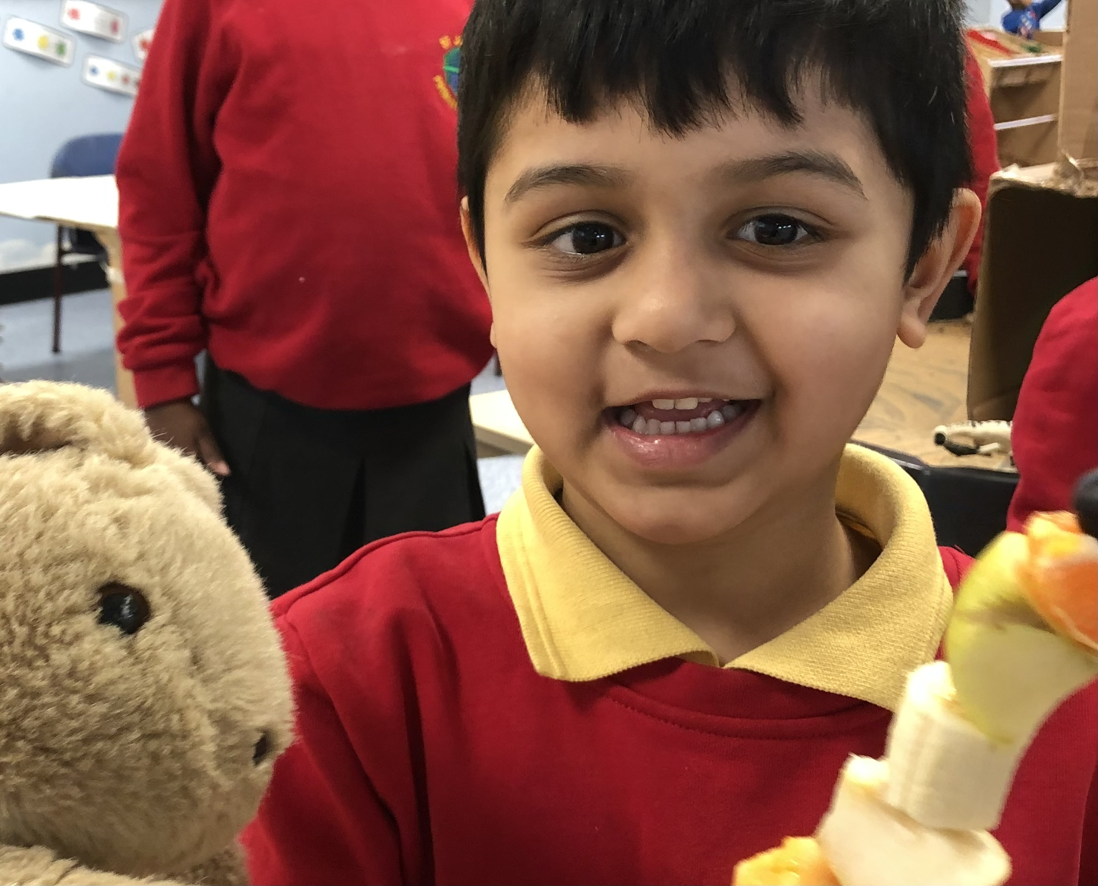
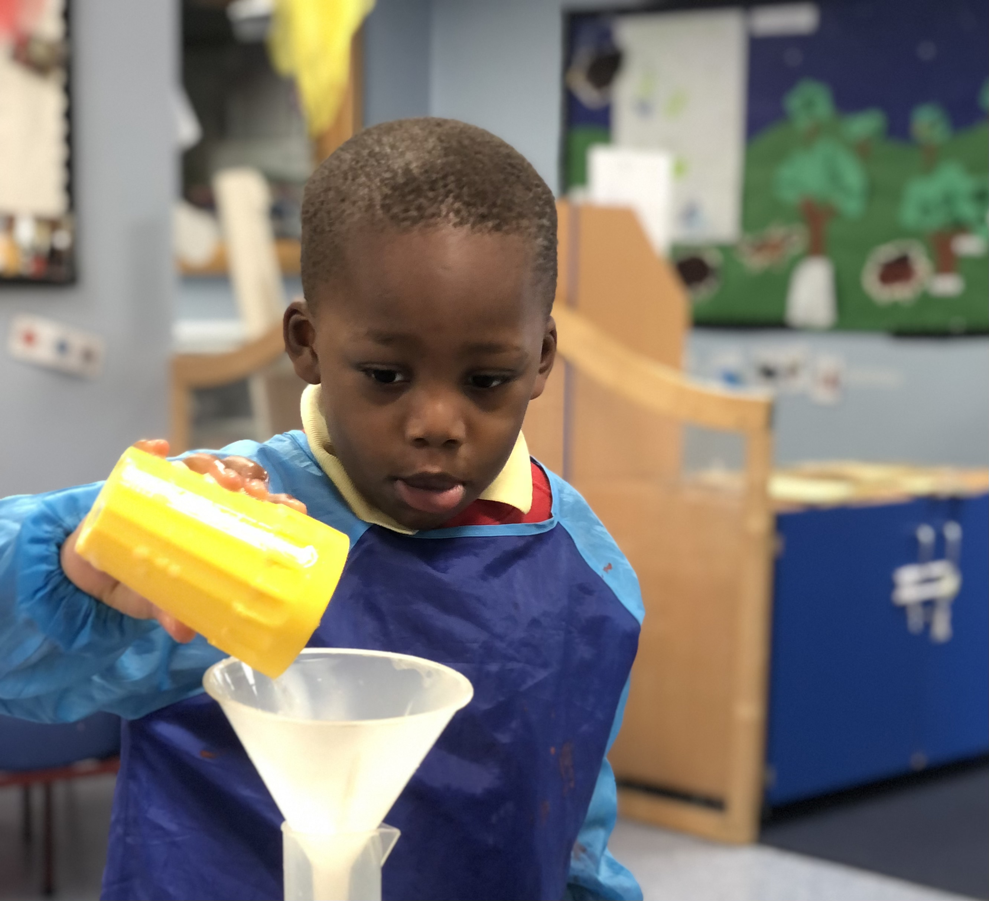
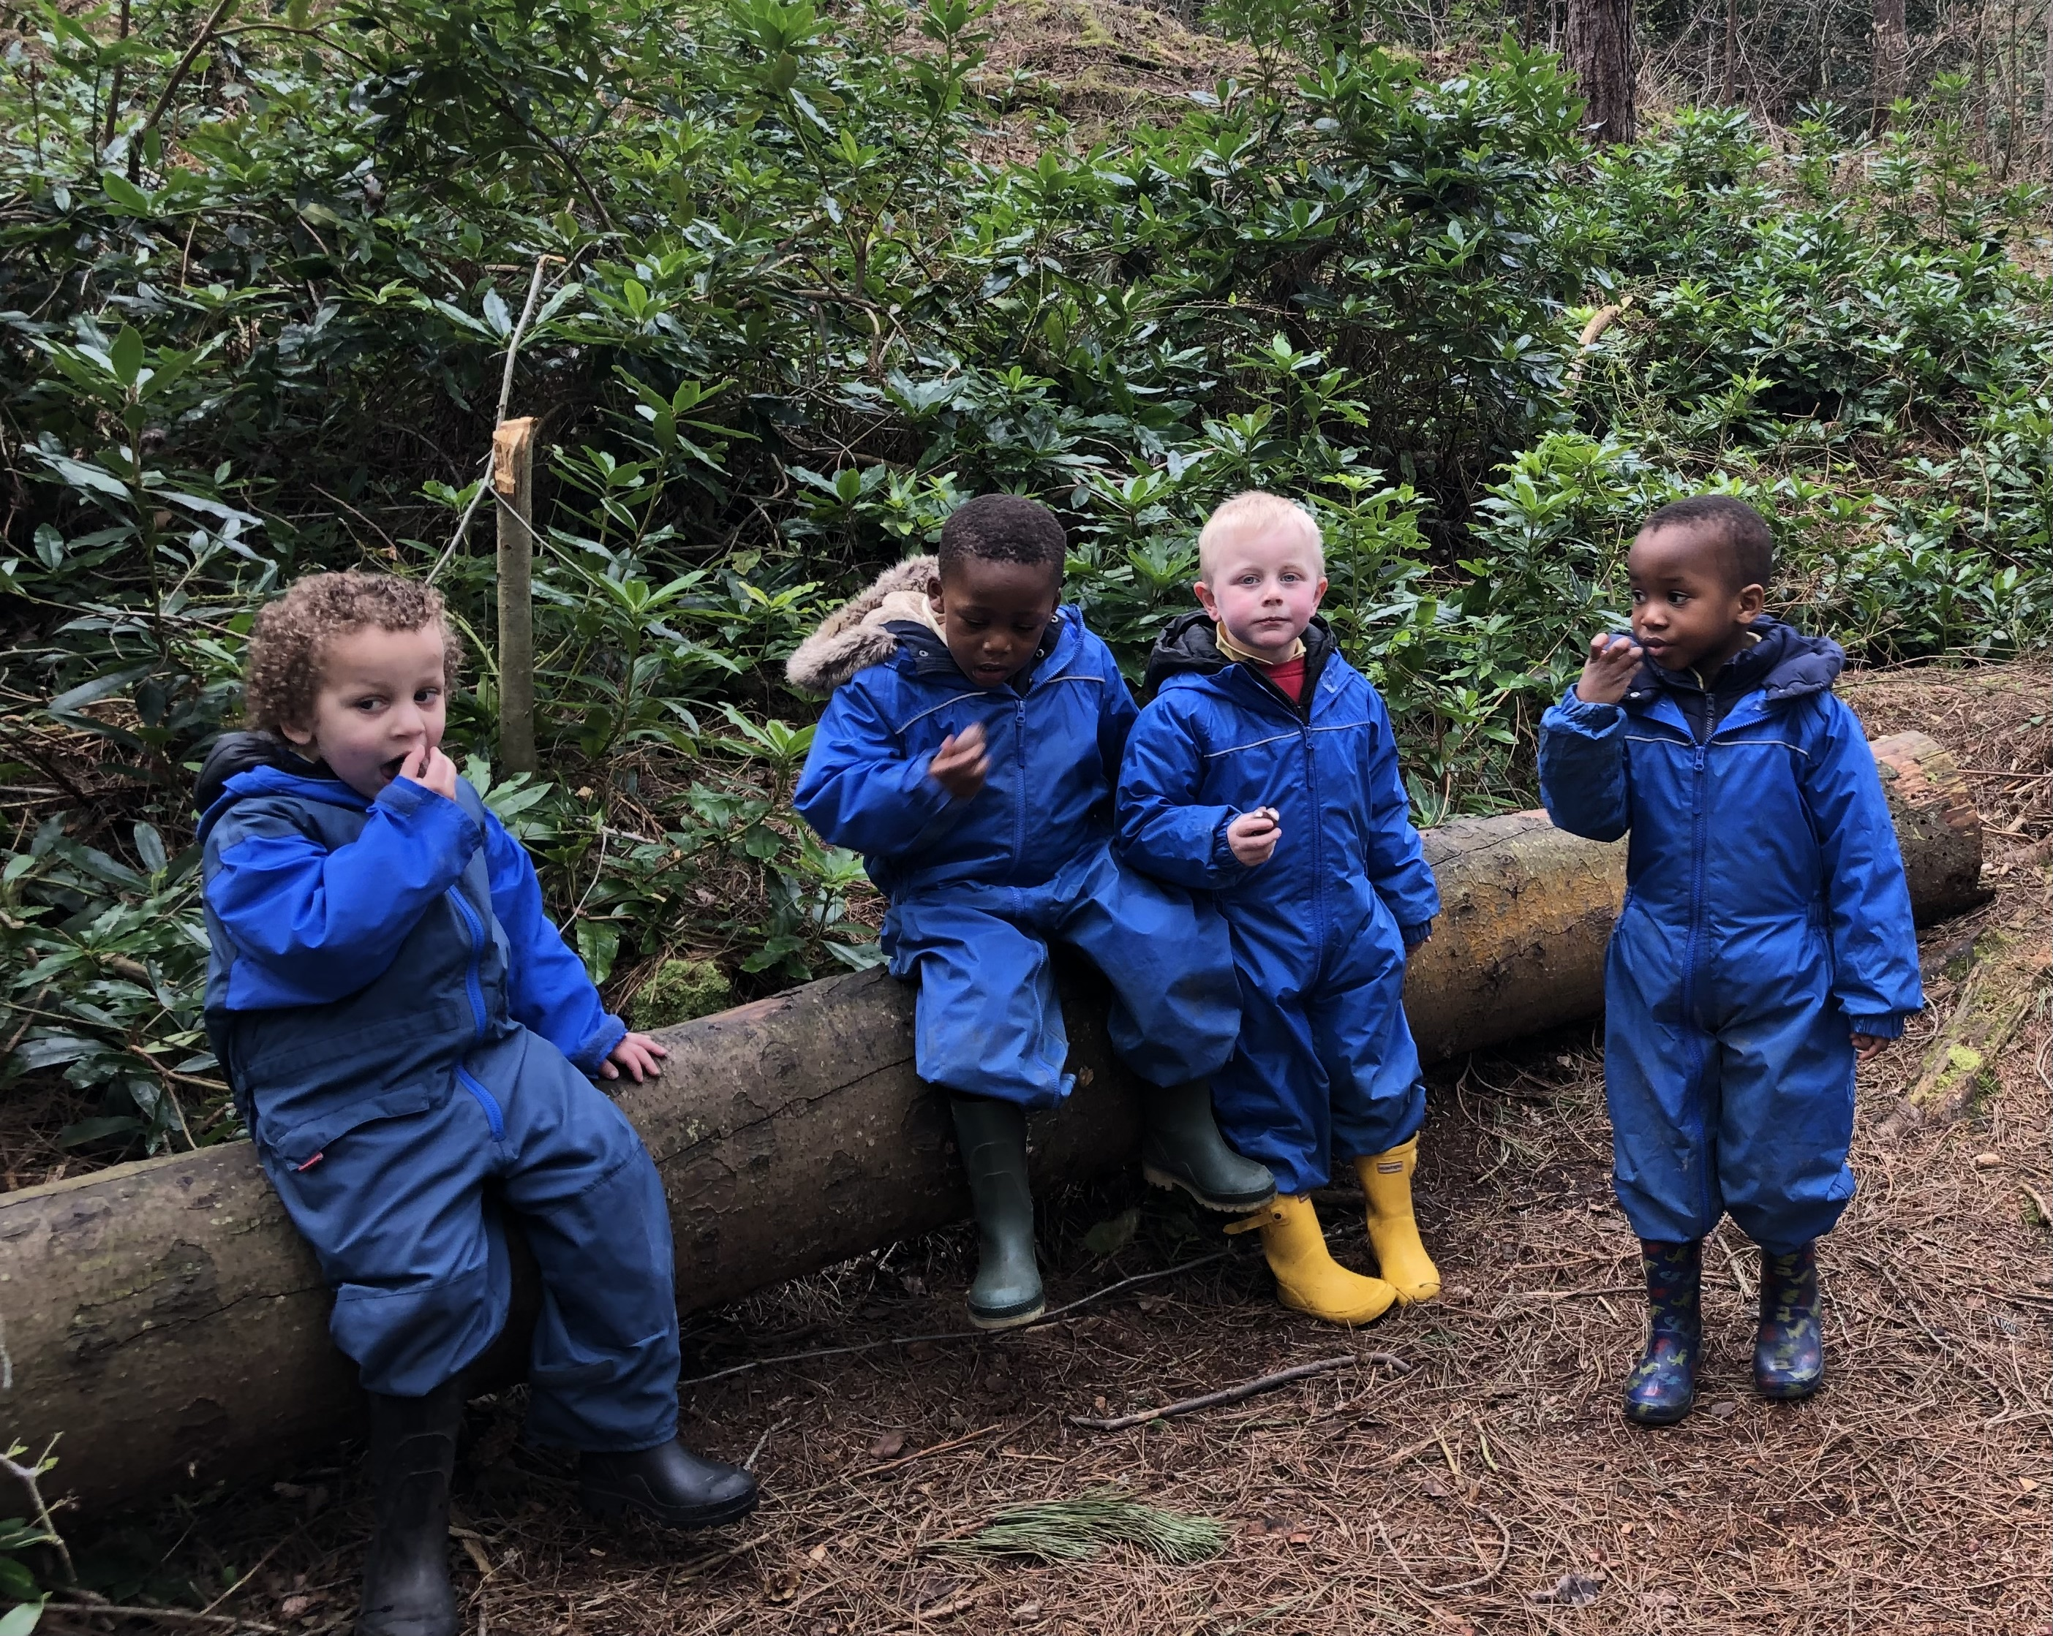

Your child’s start date:

We are looking forward to seeing _____________________________________________

On the ___________________________________________________ at ____________________________

Rational

At St John’s we aim to provide the highest quality care and education for all our children thereby giving them a strong foundation for their future learning. We create a safe and happy environment with motivating and enjoyable learning experiences that enable children to become confident and independent. We value the individual child and work alongside parents and others to meet their needs and help every child to reach their full potential.

Staff:
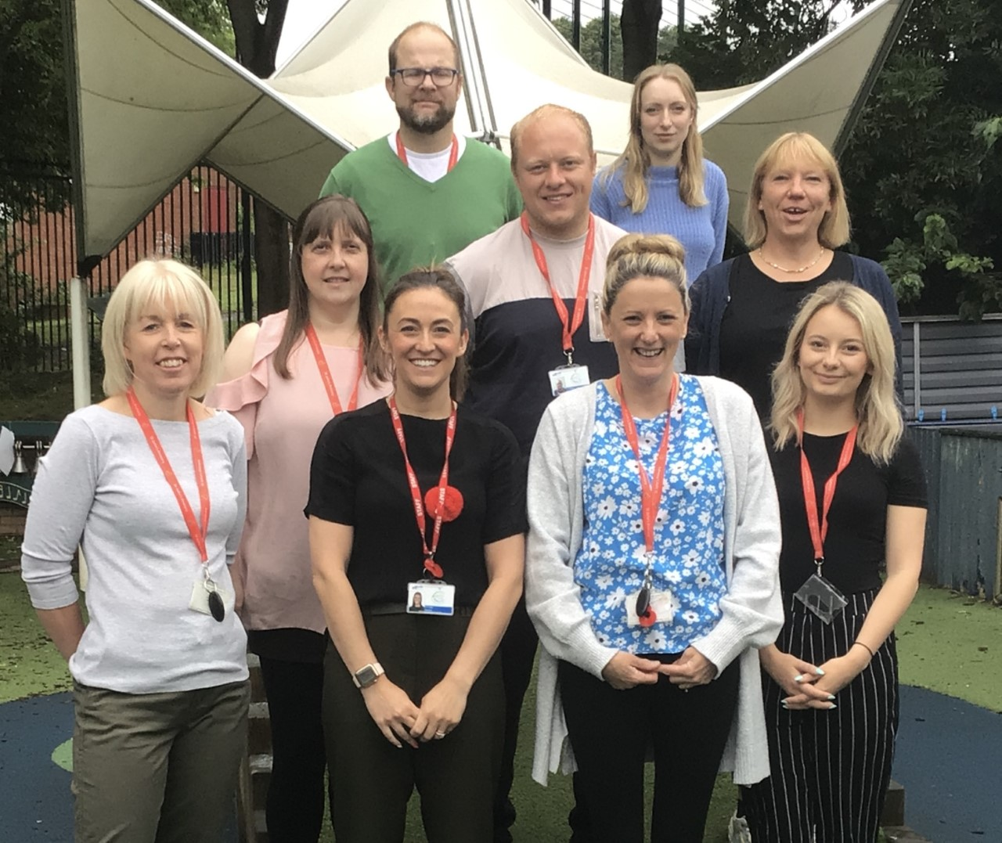
Mrs Branson, Mrs Finlay, Miss Shaw, Miss Watson, Mrs Ranson, Mr Manning, Mr Walker, Miss Taylor

Role of the Keyworker

The key person is a named practitioner who has responsibilities for a small group of children, they are there to help your child feel safe and secure. The role is important for both child and parent and it is an approach set out in the EYFS. The key person will respond to children’s needs and help them settle into a new environment. Communication is paramount between parent and key person as these discussions hold key information about the child.
The keyworker along with other staff from the Early Years team will record your child’s learning and share this with you via Seesaw.

Seesaw

Seesaw is an app to support your child’s learning. This system allows us to work with parents and carers to share information and record the children’s play and learning both inside and outside of the setting. Staff can set work for the children using the app and give written or verbal feedback. Some of this work will be completed in class. For reception age pupils some of this work may be set to be completed at home. Parents and carers are given their own log-in details to allow them to access the system. We encourage parents to regularly look at seesaw alongside their children and talk about their learning at school. We love it when parents add comments or posts too.

Procedures for admitting children – staggered intake

Children are brought into the Early Year’s Unit in small groups giving all involved the opportunity to spend quality time together and begin to build up close relationships.

Nursery

First Morning
You are asked to bring your child to school at 9:15 am on their first morning. You are expected to stay for the first morning session with your child until 10:30am. We find this helps your children feel more secure and relaxed in their new environment.

Second Morning
Your child can arrive at 9am and you are encouraged to settle your child at an activity and then leave for a short period of time. The key worker can then observe how your child manages independently in the unit. If your child is showing signs of distress we may ask you to stay in the unit until your child is more relaxed. Your child can stay until 11:30am.

Third Morning
Parents are encouraged to settle their child to an activity and then leave for a full morning session until 11:30am. If your child has coped with the full session, parents are asked if they would like to stay for lunch the following day.

Fourth Morning
Children stay from 9am-1pm which includes lunch and a play outside.

Going forward
From this point onwards, the day is then gradually extended to meet the needs of your child. Some children may cope well with a full day but some children may be tired, miss home or generally be less settled at first. We will keep you informed of how your child is doing and extend their day at their pace.

Reception Class

Children come into school more quickly in Reception class. Once you have your start date your child will start school at 9am for a full day session.

Collection times for reception children:

Monday: 9:00am – 3:15pm
Tuesday: 9:00am – 3:15pm
Wednesday: 9:00am – 3:15pm
Thursday: 9:00am – 3:30pm (whole school assembly)
Friday: 9:00am – 1:30pm or
9:00am – 3:00pm (if you choose enrichment)

Uniform

Our school uniform consists of a red sweatshirt, yellow polo shirt and either a black or grey skirt/trousers. The children will be busy with paint, playdough, glue etc and need to feel they are able to join in without worrying about spoiling special clothes.

Shoes – please help us on this one! If at all possible please send your child in Velcro fastening or buckled shoes. This encourages them to develop self-help skills and helps the staff tremendously. It also helps the children’s confidence if they have been given lots of chances to put on and take off their own clothes at home.

Early Years Curriculum

The Nature of Learning:-

Children learn through play. Play is a child’s work and provides vital foundations for future learning. Play is the medium through which the Early Years Curriculum is experienced by children. It is a very serious business since it demands from the children concentration, perseverance and mental and physical effort.

Young children learn by experience. They need to look, touch, smell, listen, taste and explore with a variety of play materials. Within the group, all children are supported in developing their potential at their own pace. By means of developmentally appropriate activities and adult support, the curriculum leads to Early Learning Goals and prepares children to progress with confidence towards the National Curriculum.

The Characteristics of Effective Learning and the Prime and Specific Areas of learning and development are all interconnected. The ways in which a child engages with other people and their environment, playing and exploring, active learning and creating and thinking critically – underpin learning and development across all areas and support the child to remain an effective and motivated learner.

Prime Area

Personal, Social and Emotional

We see this area as of paramount importance, within a secure and stimulating environment children are supported in developing self-esteem and the confidence to work, co-operate and establish relationships with others in a group outside the family.

The children are encouraged to:

- Make and express choices
- Demonstrate independence in selecting activities and resources
- Explore new learning
- Take control and responsibility for their actions and needs
- Use initiative and their developing powers of reasoning to solve the
problems they encounter in their work
- Develop the perseverance to engage increasingly complex play,
working sometimes independently and at other times collaboratively
with increasing concentration
- Know how to look after their bodies, for example using the toilet, getting dressed and brushing their teeth independently.

The same problem-solving approach applies to areas of social conflict where children are supported in verbalising their feelings, acknowledging and respecting the needs of others and working towards mutually acceptable solutions so that they develop an understanding of both self, and the part they play in a group and of what is right and wrong and why. Adult example and support, activities, stories and the sharing of experiences help to develop an understanding of a range of feelings and care for all living things, property and the environment. The children are introduced to concepts of: sharing, caring, honesty, relationships, kindness, feeling and empathy.

Communication and Language

- Children are encouraged to extend their vocabulary, fluency and listening skills by hearing, participating in having fun with and responding to stories, songs and rhymes, some of which they will commit to memory. Children talk with others about personally meaningful experiences. They plan their work for the session, communicate with others during work time and describe events, objects and relationships when evaluating their work. Adult-initiated activities in small and large groups familiarise children with the pattern, rhythm of language and introduce them letter and sound recognition. Through role-play the children develop language skills by using different modes and styles of speaking for different people and situations. They need to listen to each other’s contributions and learn to play co-operatively.
- For the children who need additional support with their speech and language skills we have a member to staff delivering Talk Boost sessions. Talk Boost is a targeted intervention aimed at 3-5 year old children with delayed language development helping to boost their language skills to help narrow the gap between them and their peers.

Physical Development

A range of large and small equipment and opportunities, both indoors and outdoors, allow children to develop confidence and enjoyment in the use and development of their own physical skills. Adult support enables children safely to meet physical challenges, developing increasing skill, co-ordination and control in moving, climbing and balancing. At the same time, children are supported in the development of the fine motor skills required to use tools such as brushes, pencils and scissors, to handle small objects with increasing control and precision and to choose the correct tool for the job. Children explore a variety of manipulative toys, which develop manual dexterity by slotting, pushing, pressing and threading.

Specific Areas

Writing

In an environment rich in print and opportunities to write , our goal is to help children to understand the power of the written word as a basis for communication, knowledge acquisition and entertainment and, when they are ready, to encourage children to use written and drawn symbols for themselves in drawing, letter-like forms, invented spellings, dictated stories and emergent writing. A variety of mark-making implements for drawing and writing are offered to the children and they are encouraged to draw and write about things which interest them and which they want to communicate. Mark-making is a very important and necessary stage in the development of early literacy. Emergent writing is positively encouraged so that children learn to communicate in the written form. Every child’s work is valued and respected. The children are encouraged to use mark-making tools in all areas of the room, such as shopping lists, telephone pads, letters and notes. We encourage and help each to transfer its spoken language into the written form. The level of writing is matched to each child’s ability. This also includes scribing for the children to enable them to compose at length. As the children gain in competence, their random marks become more precise, left to right orientation becomes apparent and their writing begins to contain recognisable letters. Children who are beginning to write independently are supported in their attempts by helping them to discriminate the initial letter sound of the work required. As competence increases, they are encouraged to discriminate and represent further sounds in these words. Children whose finer motor skills need a lot of input are encouraged to use fat crayons, paints, clay, dough and small manipulative toys to develop finer muscle tone in their fingers. The children are introduced to a cursive style of print from the beginning and this is developed by handwriting patterns and individual letter formation. Cursive writing is practised in the air, on paper, in sand, with paints, on white boards and is developed indoors and outdoors.

Reading

We encourage our children to love and respect books. Every day, a member of staff will share books with the whole class and at other times with individuals or small groups as required. We aim to share: fairy stories, poetry, factual books and picture books with the children. We help the children to develop pre-reading skills by touching each word as it is read, enabling the children to match the spoken to the written word and to follow print in the correct direction. The children are encouraged to use pictures clues and to predict events. We discuss the content of the books to ensure understanding. All these activities help the children to discover the relationship between the spoken and the written word. They discover words and pictures have meaning and discover rhymes, rhythms and patterns of words. We run a Take Home Library session once a week where the children have the opportunity to look at books and chose their favourite story to take home to share with their parent/carer. We believe that storytelling and book reading is a good way for parents/carers to have regular, additional talking time with their children. Storytelling introduces structure and language patterns that help form the building blocks for reading and writing skills. Reading to children on a daily basis gives them the best start in life.

In our Early Years the children have the opportunity to take part in Playing with Sounds, Read Write Inc and Talk for Writing to support independent reading:

Playing with sounds.

Playing with Sounds falls largely within the Communication, Language and Literacy area of learning. The activities are mainly adult led with the intention of teaching young children important skills: listening, sound discrimination, rhythm and rhyme, alliteration, voice sounds, oral blending and segmenting. When the children are ready they move onto Read Write Inc where they are taught letters and sounds.

Read Write Inc

Read Write Inc developed by Ruth Miskin, provides a structured and systematic approach to teaching literacy. It is designed to create fluent readers, confident speakers and willing writers. The Read Write Inc programme is used to teach phonics to children who are learning to read. The programme is very structured and quickly gets children blending the sounds (phonemes) they have been taught to make words.

Talk for Writing

Talk for Writing developed by Pie Corbett is an approach to teaching writing that emphasises three teaching methods:
Imitation (where children learn stories by heart, so they can discuss and dissect them) Innovation (where children adapt stories to create their own versions), and Invention (where teachers help pupils to create original stories). These tasks aim to improve writing ability by giving children an
understanding of the structure and elements of written language.

Maths

Mathematics enters every area of the Early Years and the development of mathematical concepts are happening all the time. Through their play and by means of adult-supported practical experiences children become familiar with sorting, matching, ordering, sequencing, recognising and creating patterns and counting everyday objects.
Elements of the daily routine such as preparing snacks, counting those present, number games, songs, rhymes and number-related activities such as jigsaw puzzles help children recognise and use numbers to 10 (and beyond, where appropriate).
Children use their developing mathematical understanding to solve practical problems and their developing mathematical vocabulary to describe shape, position, size and quantity, simple addition and subtraction, doubling, halving and sharing. Early mathematical concepts are developed such as sorting, matching, colour, pattern, size and number.

Understanding the World

A safe and stimulating environment allows children to explore and experiment with a wide range of natural and manufactured materials. They learn to observe, talk and ask questions about and sometimes record features of objects and substances and to recognise differences, patterns, similarities and change. Children are assisted both indoors and outdoors in exploring and understanding their environment, their families and past and present events in their own lives. They explore, care for and recognise features of living things, e.g. in the garden and with visiting animals. The children explore a range of found materials. They are involved in planning and decision making, cutting, placing, fixing and fastening. Language skills are developed as children talk about what they have made. At times they are asked to make something to meet given criteria. They have the opportunity to explore a full range of materials and to select the most appropriate materials and make their desired model. They are encouraged to test their work and amend and improve as appropriate.
Children will have opportunities to go to the computer room to use PC’s and have access to iPad’s in the classroom. There is a range of programmes to enable the children to develop hand/eye co-ordination leading to fundamental keyboards skills. Our programmes allow the children to draw and paint pictures and engage in early reading and numeracy activities. We aim to give the children the experience of as many techniques concerned with the safe preparation of food as possible, such as stirring, chopping, grating, mixing, rolling and squeezing. Everyone has the opportunity to smell, feel, taste the foods and observe the scientific changes when foods are: beaten, frozen, baked and mixed together.

Expressive Arts and Design

Children are encouraged to use their senses and a wide range of resources in order to express their own ideas and feelings and to construct their individual responses in two and three dimensions. Art equipment, including paints, glue, crayons, and pencils as well as natural and discarded resources provide for open-ended exploration of colour, shape and texture and the development of skills in painting, drawing and collage.
Children join in with and respond to music, dance and stories and there are many opportunities for imaginative role-play, both individually and as part of the group. Art and music sessions are planned for to widen the children’s experiences and to give them opportunities for exploration and self-expression. The children experience guided role-play sessions through Mantle of the Expert. This is an educational approach that uses imaginary contexts to generate purposeful and engaging activities for learning.

Mantle of the Expert
Mantle of the Expert works by the teacher planning a fictional context where the children take on the responsibilities of an expert team. As the team, they are commissioned by a client to work on an assignment, which has been planned to generate tasks and activities that will involve them in studying and developing wide areas of the curriculum.

Forest School
- Over the next academic year your child will have to opportunity to take part in Forest School sessions. A timetable will be displayed on the classroom window indicating which group your child will be in.
- The aim of forest school is to provide regular opportunities for all children to learn outdoors in a woodland setting. The children get to take part in positive learning experiences, where they will develop self-confidence and self-esteem. These activities can be self-chosen where the children can follow their own interests as well as taking part in guided sessions such as identifying trees, birds, flora and fauna, making fires, using tools and getting muddy! Forest school sessions bring learning to life and encourage the children to reflect and review their learning, take risks and become independent. Forest school is a very positive experience for both children and adults and our aim is for all children to have fun, learn and build on their experiences.
- It is important that all children have appropriate clothing suitable for all weather conditions. The school will provide waterproof jackets, trousers, and high-viz florescent vests. Regardless of the weather all children are expected to wear long sleeves, long trousers, and strong shoes always. This will protect them from the sun, stinging plants etc. Wellies should be worn on wet days. Sun hats are necessary for sunny days.

If you have any other questions that are unanswered in this booklet, please feel free to contact the Early Years Lead,
Mrs Branson at Roberta.branson@stjohns.newcastle.sch.uk

