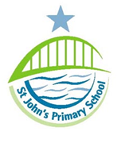

The Governing Body of St John’s Primary School is consulting on changes to their admission arrangements for the academic year 2025/26.
The key changes proposed are an addition to the allocation criteria:
Children with a parent/guardian/carer who is employed by St John’s Primary School. where the member of staff has been employed at the school for 2 or more years at the time at which the application for admission to the school is made or the member of staff is recruited to fill a vacant post for which there is a demonstrable skill shortage.

Please see the school website for proposed details of the full policy.
www.stjohns.newcastle.sch.uk
The consultation is open until Tuesday 20th January.
Comments or queries should be addressed to
The Governing Body
St John’s Primary School
Teindland Close
Benwell
Newcastle
NE4 8HE
or emailed to: admin@stjohns.newcastle.sch.uk

