

**Careers in Construction**

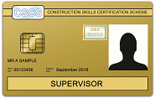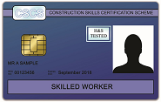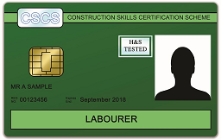

**A 6 day course that will equip you with the essential skills to gain access to construction sites.**

**Upon successful completion of the course, learners will gain:**

* Level 1 Award in Health and Safety in Construction
* Level 1 Award in Construction Crafts
* CSCS Test (re-sits will not be funded)
* CSCS Labourers card or higher
* Support onto next route - Further Learning, Apprenticeships or Employment



**May 2nd, 3rd, 4th, 8th, 9th and 10th**

**9.30 – 3pm**

**Tyneside Foyer Newcastle**

To book your place or for   
further information call  
  
**01670 841262**

**Eligibility Criteria:**

**16-18 years old**  
Unemployed/Not in any other Education or Training

**19 years old and over**  
Unemployed/must be claiming JSA/ESA/UC