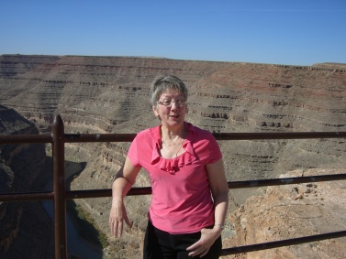
I’m the current Chair of the Governing Body and have held this position for several years.
Before I retired I worked in schools as a teacher and later a head teacher. I also did some work as an Additional Inspector within Initial Teacher Training and trained as an Inspector for schools.
Since retiring I’ve been very involved in the Voluntary Sector working as a member of the Elders Council of Newcastle and as an advocate for people with mental health problems. In my spare time I’m is a choir member and enjoy playing in steel pan bands as a complete change from anything else!
I got involved in the work of governors as I knew from experience how hard it was for schools to find people willing to be governors. I made enquiries at the City Council and was asked if I had a school in mind; as I didn’t I was lucky enough to be offered a place on the Governing Body of St John’s.
Since joining the Governing Body the school has changed enormously in all sorts of ways. There’s a much bigger staff and the mixture of cultures is very different but interesting and the building has changed too and now it’s becoming part of a Trust. What hasn’t changed is the dedication of all the staff led by an inspiring head teacher to make sure every child at St John’s is given the very best education so they are able to aspire to be anything they want to be in the future.
Because of my background in education I’m able to offer support to staff as well as bring a measure of understanding in a wide range of areas such as training; staff recruitment; current legislation; teaching and learning; leadership. It’s hard work and it does take up time to understand, prepare for meetings and to visit; however the rewards are hearing of the many successes (and these are not all about tests); listening to the children speak with clarity and affection about their school; understanding all of the effort made by a large number of people that make the school such a great place to learn, grow and become educated, caring and well-balanced citizens of the future. It’s a pleasure to be part of such a thriving community.

