St John’s Primary School
Teindland Close,
Newcastle upon Tyne
NE4 8HE

Tel: 0191 273 5293
Fax: 0191 273 0651

Dear Parents,

Thank you for choosing St John’s Primary School for your child. You have made a wise choice.

The aim of this booklet is to provide you with some information about our school with regard to our aims, organisation and policies.

We provide a happy and caring atmosphere in which your children will learn and develop to their full potential. To achieve this we aim to provide a welcoming but safe school, so that we can establish a relationship between home and school, based on trust and shared knowledge.

We hope you find the information in this booklet clear and useful.

If there is anything you would like to discuss with me at any time, you only have to ask or arrange an appointment.

I look forward to working with you and your child in the years ahead.

Yours sincerely,

Mrs. Tracey Caffrey
Headteacher
AIMS OF THE SCHOOL

The school aims to provide a stimulating, caring environment in which children will be encouraged to develop in every way.

All members of the school community, both adults and children, are encouraged to value, respect and care for each other.

We welcome the involvement of the whole community, especially parents, as we recognise that the child’s life in school is closely linked to family life.

We aim to provide the very best education matched to the needs of each child. We also aim to ensure that children enjoy the special pleasures of childhood for their own sake.

‘Learning to Live, Living to Learn’

St John’s Staff

Leadership Team:
Head Teacher Tracey Caffrey
Assistant Head Teachers Guy Rundle
Kelly Bewick
SENCO Gillian Howden
Phase Leaders KS1 Miranda Shaw
KS2 Kelly Bewick
EYFS Manager Shelley Hynds
Business Manager Marie Bartley

Parent Support Advisor Susan Lishman

Teaching Staff:
Nursery Jodi Lowther
Reception Shelley Hynds
Year 1 Rachael Gray/Roberta Branson
Year 2 Gillian Howden
Year 3 Miranda Shaw
Year 4 Ian Gorman
Year 5 Guy Rundle
Year 6 Kelly Bewick

Cover teacher Katie King

Teaching Assistants
HLTA Debbie Ranson
EYFS TAs Julie Watson, Joanne Stephenson, Michelle Hadfield
TAs KS1 Leanne Turner, Amanda Taylor, Leanne Harrison
TAs KS2 Melanie Booth, Jan Gowland, Jacqui Hodgson, Donna Holford

Midday Supervisor: Lisa Swan
Extended Schools Co-ordinator Lee Breheny, The Turf@St John’s
Site Manager: Jimmy Rogers
Administrative Officer: Joyce Marshall
School Nurse: Melissa Smith
School Cook: Liz Robinson

THE GOVERNING BODY

Governors – Who are they?
The Governing Body consists of parents, members of the local community, teaching and non-teaching members of staff and representatives of the Local Education Authority.

What do they do?
They meet at least twice a term in school, and they help with all aspects of the running of the school including interviewing and selecting staff, discipline procedures and finance. They produce an Annual Report to parents.

Can I become a Governor? Yes.
Parents elect three Parent Governors who serve on the Governing Body for a period of four years. If you are interested in becoming a Parent Governor please contact the Headteacher for details.

Listed below are the current members of the Governing Body from September 2017:-

Term of Office
Associate Governors
Marie Bartley 09/07/2014 - 08/07/2018
Jimmy Rogers 17/03/2015 - 16/03/2019

Local Authority
Mary Nicholls Chair 02/05/2007 - 01/05/2019

Co-opted
Hannah Morrow 17/03/2015 - 16/03/2019
Dave Douglas 08/03/2016 – 07/03/2016

Headteacher
Tracey Caffrey 18/03/2015

Parent
Razmin Begum 27/06/2013 - 26/06/2017
Maka Bekurishvili

Staff
Susan Lishman 01/02/2015 - 31/01/2019

Co-opted Staff

FURTHER INFORMATION ABOUT OUR SCHOOL

The following documents are available on request from the Headteacher or can be found on the school website:-

a] Curriculum Policy Statements
b] The governing body’s statement of curriculum aims
c] Reports on the impact of Pupil Premium and Sports Premium funding
d] Ofsted reports on the school
e] The school’s policies for RE and sex education
f] Arrangements for complaints about the school’s curriculum

CHARGING POLICY
Pupils take part in a variety of outings/activities which support and enrich the curriculum. Parents are sometimes asked to contribute towards the expenses and the rest is met from school funds. We ask parents for written permission, except for short excursions within walking distance of the school e.g. to the library and local church. In rare circumstances, where children’s behaviour gives rise to concerns about safety, it may be necessary to exclude the child from special outings or ask parents to attend the outing.



ATTENDANCE
Good attendance is essential. We will always ask parents for an explanation for all absences.

Authorised absences include:
- Illness
- Medical/dental appointments, although we do ask that these are made outside of the school day wherever possible
- Observance of some religious holidays

Unauthorised absences
e.g. Birthdays, haircuts, visits to town/shopping etc.

Children who obtain 100% attendance for the year are presented with a shield at the end of the Summer Term.

ABSENCES FROM SCHOOL

Please let us know as soon as possible by telephone or a note if your child is absent. Ring either the school office on 0191 2735293 or Mrs Lishman on 07815968699 and leave a message. Failure to notify the school of absences is recorded as an unauthorised absence and a truancy record soon builds up. If attendance levels fall, school will notify our Attendance Officer, who will visit you at home and monitor your child’s attendance.

A list of school holidays is sent to parents at least once a year and is available on the school website. The governors encourage parents to arrange family holidays during school holidays. Parents should fill in a holiday form (available from the office) which is then passed to the headteacher to keep a record. No holidays taken in term time will be authorised. Please avoid taking any holidays in May or June as this is when formal testing takes place in Key Stages One and Two.

Although we realise that parents try to make appointments outside of school hours, if you do need to collect your child during school hours, please let us know in advance and collect your child in person.

SCHOOL HOURS


Morning Session: 8.55 a.m. –12.10 KS1/KS2

Break time: 10.30 a.m. - 10.45 a.m.

Afternoon Session: 1.00 p.m. - 3.30 p.m.

Children in Key stage 1 will have a short break in the afternoon.

Breakfast club is open daily to all pupils, free of charge. Doors open at 8am and last admission is 8.30

Dropping children off in the morning
We expect that all children in Year 4 and younger are escorted to school by an adult and that the adult will wait with the child until they are handed over to a member of staff at 8.55am (or to Breakfast Club staff between 8am and 8.30am). Children should not be left unattended in the yard before 8.55am as there is no member of staff available to supervise the children before the start of the school day. Children in Years 5 and 6 should also not be in the yard prior to 8.55am, for safeguarding reasons.

TERM DATES

Term dates and a list of holidays are available from the school office or on the school website

ADMISSION

Registration for entry into Nursery may be made at any time during school hours by calling at the Administrative Office and completing an admission form. To register your child for reception class, please complete an online application form direct to the Local Authority. The deadline for this can be found on www.newcastle.gov.uk To enrol your child into any other year group, please collect a form from the school office, returnable to the Civic Centre.

Before your child is admitted into school, parents should attend a welcome meeting with the school’s Parent Support Advisor.

The school operates an Early Years Unit in line with the Government’s recommendations for teaching of the Foundation Stage. Your child will work in the Early Years Unit for two years, moving into Key Stage One at beginning of the Autumn term after his/her fifth birthday.

Normally children remain at this school until the end of the Summer term of the year in which they are eleven, or before the 31st August, when they transfer to the Secondary School of your choice.
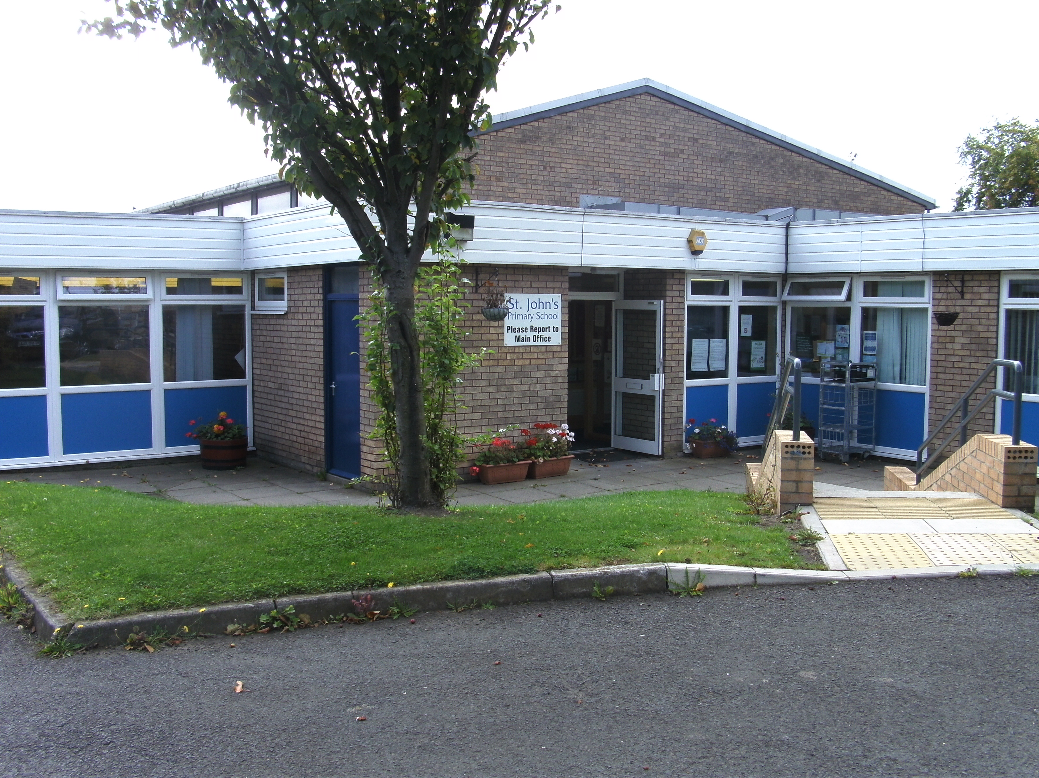

PREPARING FOR THE EARLY YEARS UNIT
Show your child the special booklet provided and tell them about the things they will be able to do in school. Encourage your child to be independent, to try to dress, feed, and tidy up for themselves. They should be clean and dry during the day, and able to manage by themselves at the toilet.
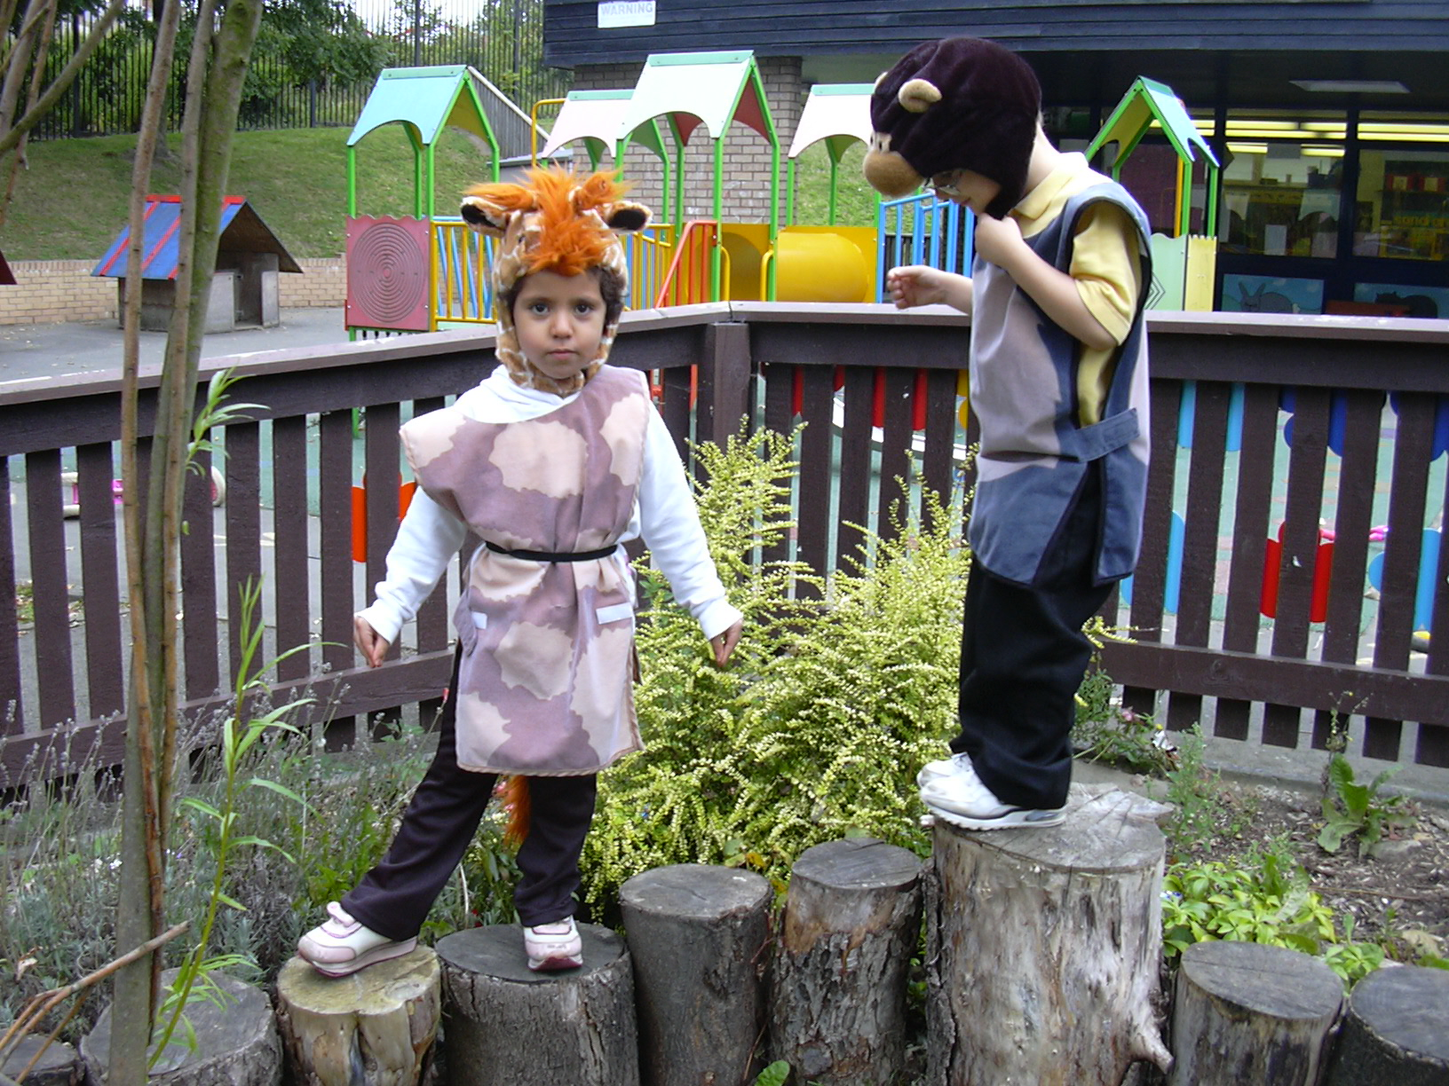

EMERGENCY AND ACCIDENTS


We must have two telephone numbers or addresses at which you can be contacted in the event of an emergency. If this information alters, please inform school at once.

MEDICINES

We need to know of any medical problems that children have. Any parent who wishes a child to attend school and be given medication during the school day must make an appointment to come into school and complete a Health Care Plan or Medication form.

HEALTH AND WELFARE

The School Health Service regularly reviews your child’s health and progress.

Our School Nurse visits the school regularly and keeps a record of the children’s health. They can be contacted through the main school office.

Your child will be tested for sight and hearing and you will be given the appropriate advice. Dentists will examine your child’s teeth and recommend treatment if it is needed.

Speech therapists work closely with teachers and doctors to help children who have speech difficulties.

SPECIAL EDUCATIONAL NEEDS

Children with Special Educational Needs will be identified as soon as possible and offered appropriate support. This will be organised by Mrs. Howden, the school’s Special Educational Needs co-ordinator. She will discuss each child’s needs with the class teacher and the parent.

When a child is not making the expected progress for any reason, we would involve the Educational Psychologist for further advice. At all stages there is full consultation with parents.

The school follows the Special Needs Code of Practice, which may be viewed on the website.
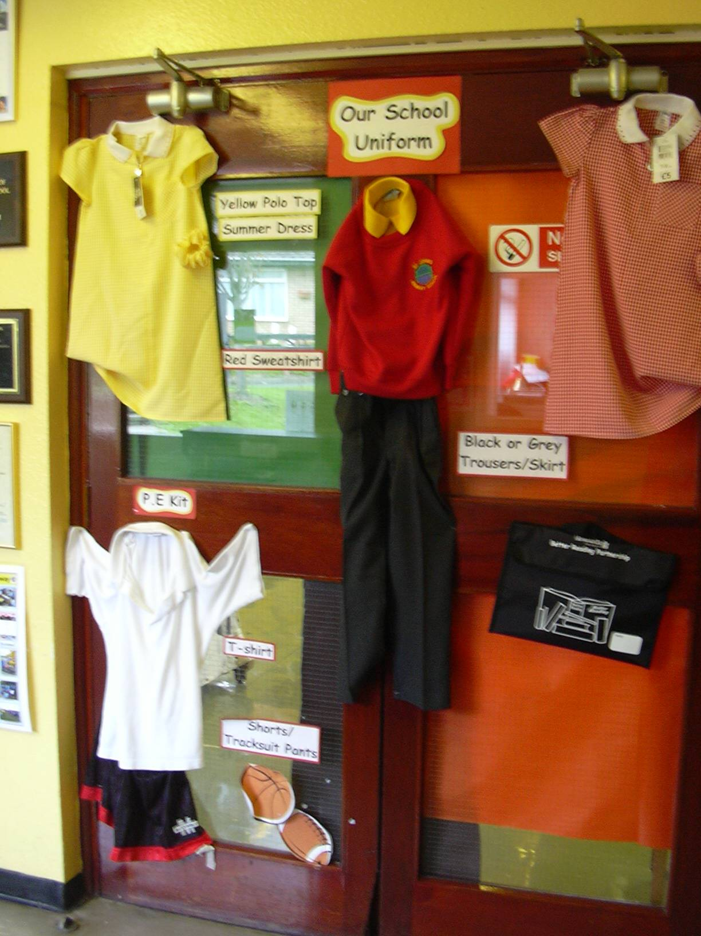
SCHOOL CLOTHING

The school has a uniform of red sweatshirts, grey/black trousers or skirts and yellow t-shirts, which children are actively encouraged to wear. Jeans and tracksuit bottoms are not allowed. The sweatshirts with logos on can be ordered through the School Office, by the Admin. Officer. Most shoes or trainers are fine, but please ensure they are appropriate for school (e.g. no high heels).

Year Six are the oldest cohort in school and in order to stand out as so, they wear a different uniform. Their uniform consists of a blue v neck jumper, white shirt and red and blue tie. Grey or black trousers should be worn, but no jeans or tracksuit bottoms.

For PE lessons, children should wear a plain white t-shirt (no logos) and blue or black shorts. Spare kit is kept in school and will be provided for children without the correct clothing. Trainers or plimsolls must be worn for all outdoor games lessons.

The school office keeps a stock of uniform and PE kit which is available to purchase.

We must advise parents that children who wear jewellery in school are in danger of accidents. Only the wearing of stud earring and a watch is acceptable in school. The Governing Body will accept no responsibility for injury caused by a child wearing jewellery. Staff can not be responsible for the removal and replacement of earrings etc. The school will not be held responsible for the loss of any jewellery on school premises.

Please tie back long hair with a hair band or bobble. We ask that boys’ hair should not have shaved markings such as ‘tramlines.’ Extreme haircuts such as Mohican-style cuts are ‘0’ cuts are not permitted.

SCHOOL MEALS

Children who stay for dinner may either have a school meal or bring a healthy packed lunch. Dinner money should be brought in on a Monday for the whole week or paid online at Lunchshop. Children are not allowed to leave school premises during the lunch break unless they go home for lunch or have obtained the Headteacher’s permission. Any child who goes home for lunch must not return to school before 1pm.

Lunch is served in the dining hall from 11.45a.m for Early Years. The weekly menu is displayed on the notice board in the hall, where meals are served and can be selected from home via the Lunchshop website. A glass of water is provided. Please make sure that unbreakable containers and no glass bottles are used for packed lunches. Packed lunches are stored in the hall until lunchtime. If you provide a packed lunch for your child, please be advised we operate a ‘1 snack only’ policy and fizzy drinks are not allowed.

We expect all children to be well behaved under the supervision of the lunchtime staff. Repeated bad behaviour at lunchtime may lead to exclusion for lunch.

Parents are entitled to claim free meals for their children if they receive Income Support. The Secretary will provide application forms and these can be returned to school or the Civic Centre. They must be accompanied by proof that the parent is in receipt of income support. We will inform you when entitlement to free meals is due to expire.

THE CURRICULUM
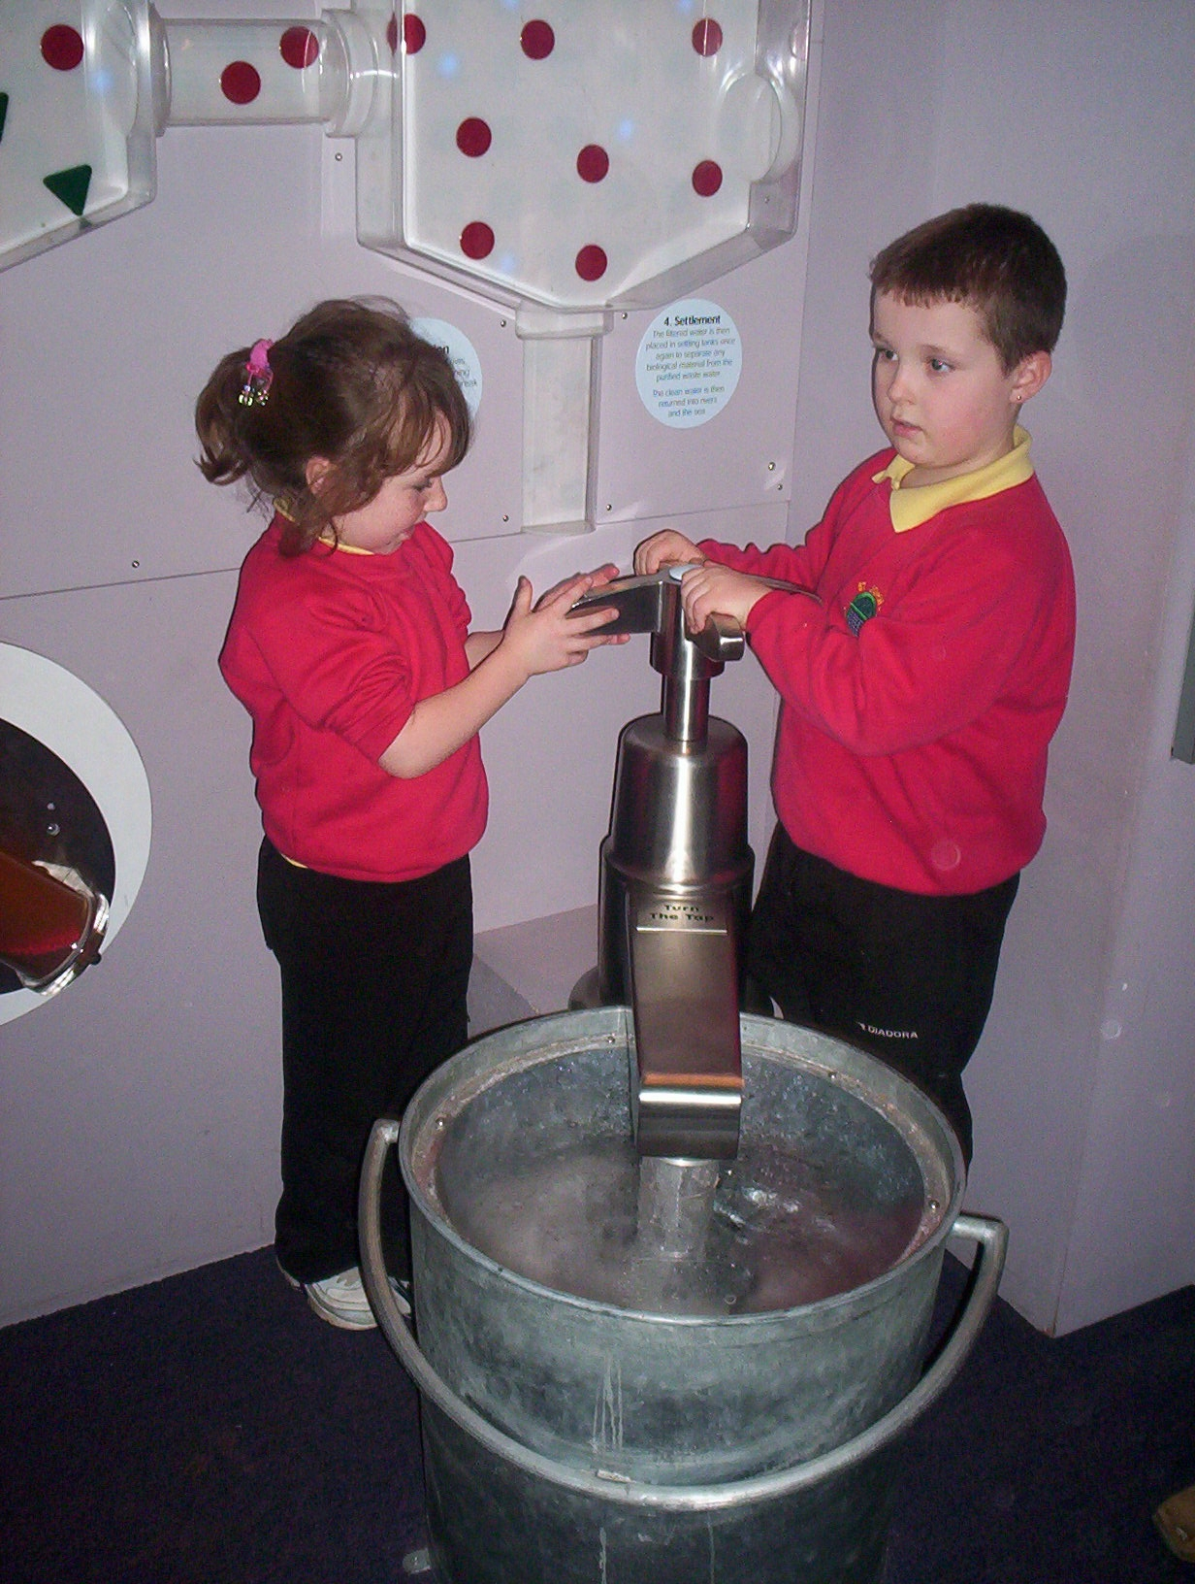
All of the subjects of the National Curriculum are taught throughout the school. They are English, Mathematics, Science, Design Technology, ICT, History, Geography, Art, Music, Physical Education, PHSE and Citizenship and RE.
National Curriculum tests are administered at the end of Key Stage One [in Year 2] and the end of Key Stage Two [in Year 6] to support assessments carried out throughout the year by class teachers.

RE and SEX EDUCATION
Religious Education is taught from Newcastle LA’s agreed syllabus which is broadly Christian. Parents are entitled to withdraw their children from RE and collective worship if they wish. Arrangements can be made with the Headteacher.
Details of our sex education policy will be shared with parents at the appropriate time. Parents also have the right to withdraw their children from these sessions.

SCHOOL RESULTS 2017

The School’s results for KS1 and KS2 can be found on the school’s website.



EXTRA CURRICULAR ACTIVITIES

We hold a club most evenings, which offers a range of activities including gymnastics, football, Fit Kids, gardening, art and dance. Family learning provide a variety of adult learning courses including Literacy, Numeracy, and basic ICT. The courses are delivered in schools for parents to support their children’s learning. If you are interested in any of the above courses, please contact the secretary at the school office.
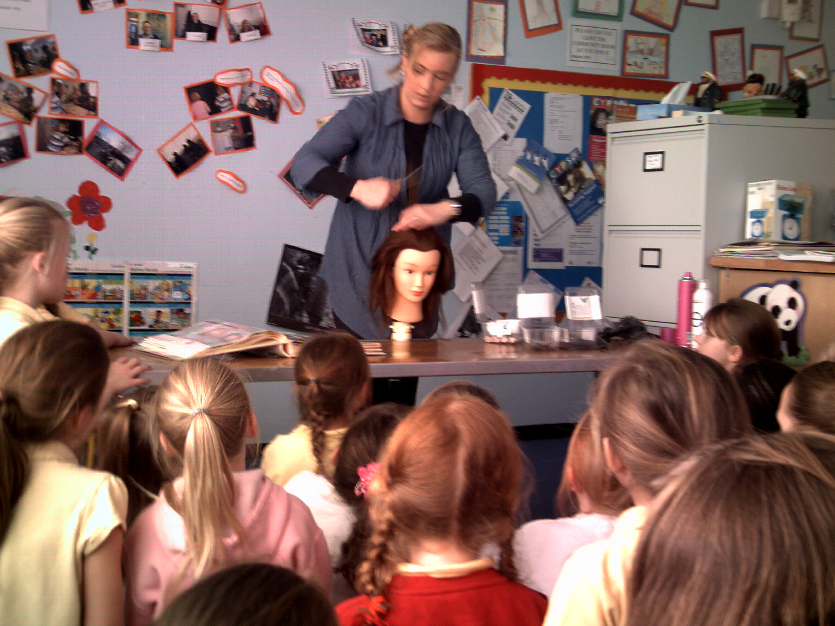
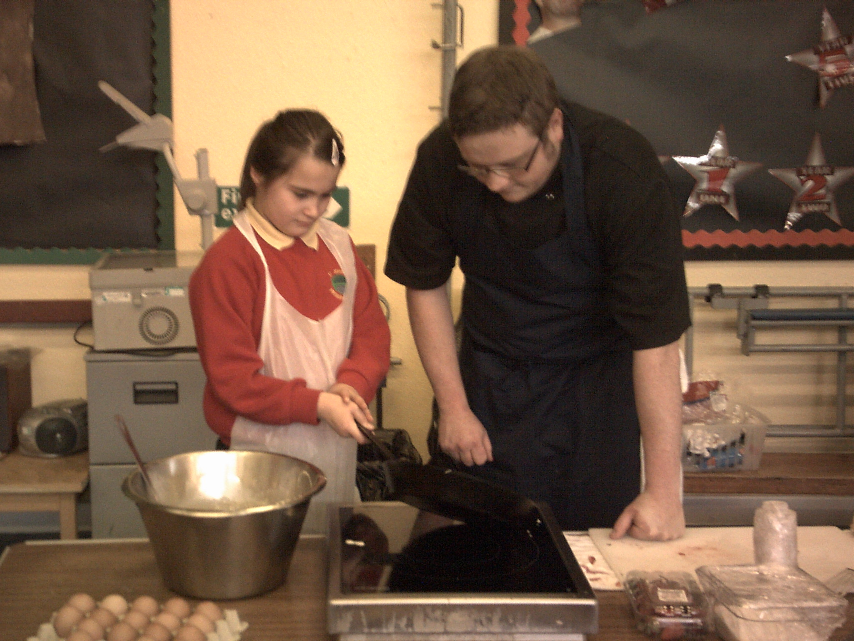

SPORTING AIMS AND PROVISIONS
Physical Education provision is appropriate to the age of the child. Sporting activities include football, cricket, basketball, netball, swimming, rugby, Zumba dance, Karate and Boxercise. Our aim is to encourage children to enjoy taking part and developing team spirit, not simply winning at all costs. Friendly games are arranged with other schools, and the football team take part in the local schools’ junior league.
We are fortunate to have our own astro turf multi sports pitch in school and the use of West Denton swimming pool.

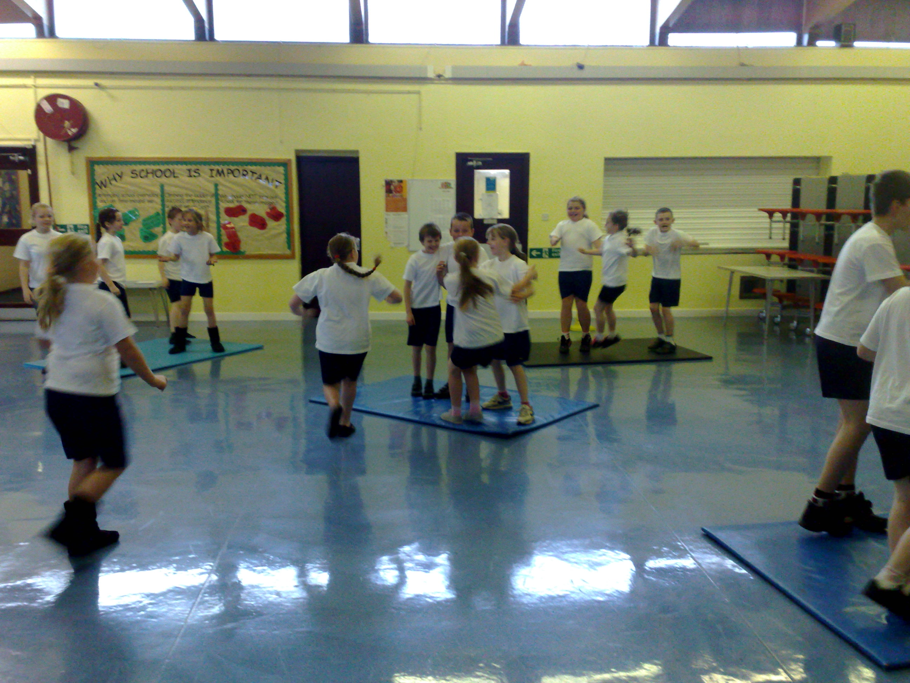

CODE OF CONDUCT
The school has a code of conduct. Pupils are expected to act with courtesy and consideration at all times.

Our school aims are simple, to ensure the safety and happiness of all who use the school. We have 6 Golden Rules, which are –



Parents are welcome to see a full copy of our code of conduct

