Informal Consultation questions about Trust status
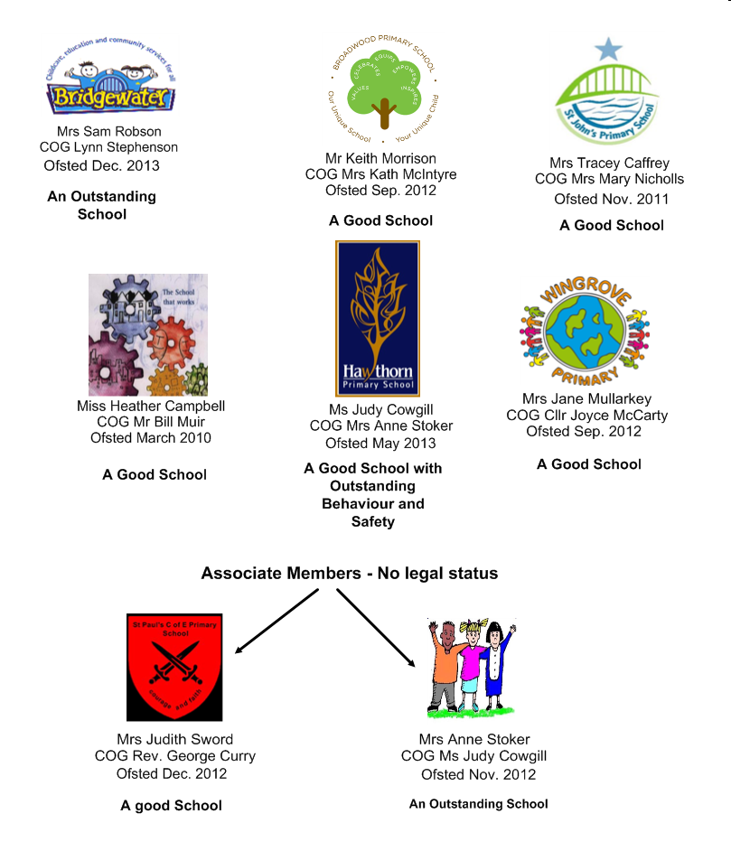

1. How do you feel about our school adopting Trust status?

I support the proposals
I don‘t think the school should become a Trust school
Comments

2. The Trust will appoint governors who have the expertise to help the school to make the vision a reality for all our pupils.
Our vision is:
The Trust will take responsibility for all children and young people in our schools. By strengthening our current partnership, the Trust will improve every opportunity and enable every learner to achieve the best they can.
How do you feel about this vision?
I agree with the vision

I don‘t agree with this vision.

Comments

General
3. Do you have any other concerns or suggestions that we should think about before we publish formal proposals?

