Newcastle
West End Schools’ Trust

Prospectus & Business
Plan
Spring 2015

HT Mrs Tracey Caffrey
COG Mrs Mary Nicholls
Ofsted Feb 2014
A Good School
HT Mr Keith Morrison
COG Mrs Kath McIntyre
Ofsted Sept 2012
A Good School

HT Mrs Sam Robson
COG Lyn Stephenson
Ofsted Dec 2013
An Outstanding School

HT Mrs Judith Sword
COG Mr George Curry
Ofsted Dec 2012
A Good School
HT Ms Judy Cowgill
COG Mrs Anne Stoker
Ofsted May 2013
A Good School with outstanding behaviour and safety

HT Mrs Jane Mullarkey
COG Cllr Joyce McCarty
Ofsted Sept 2012
A Good School
HT Mrs Heather Campbell
COG Mr Bill Muir
Ofsted Nov 2014
A Good School with many outstanding features

We welcome you to the Newcastle West End Schools’ Trust which was formed on 1st February 2015

The WEST Trust is a foundation trust of seven primary schools located in the inner west of the city of Newcastle upon Tyne. We are responsible for the education of over two thousand six hundred pupils between the ages of 3 and 11. We are a strong learning community where our pupils have highly positive experiences and attain good standards.

Our school catchments cover an area of ten square miles that are bordered by the tidal stretches of the River Tyne, the Northumberland County boundary and the main conurbation of the City of Newcastle. We have a rich industrial and historic heritage with Hadrian’s Wall bisecting our cluster. Our catchments are socio-economically mixed but when pupils leave our schools they are well prepared for the next phase of their educational journey with standards at and above the national averages in reading, writing and mathematics. All of our schools are unique and although they may vary in size and context, Ofsted inspections for our cluster reveal effective schools that work in collaboration for the benefit of the whole of our community.

Currently we employ over two hundred and fifty teachers, teaching assistants and administrative staff. Our leadership teams of experienced headteachers and governors, deputy and assistant headteachers and school business managers have proven track records of school improvement. The Trust will strengthen the schools’ collaborative work with identified key partners to further improve standards and enhance opportunities for children, parents, staff and the wider community. This prospectus gives some essential information about the Trust and includes an outline business plan for the first year of operation.

We encourage all members of the community to get involved and support us in our quest to build a strong learning community.

We want to work with partners who:

- have an interest in education
- have strong links and interest in the North East and / or roots in the North East
- have values and ethics that are compatible with the Trust
- can provide further opportunities for our local communities to flourish and ensure our children grow up to be active members of society.
- can support our vision, drive and enthusiasm for positive change.
- will genuinely enhance what we already do and have the capacity to do it.
- will allow time for the board member rep / other people to be involved
- will come with ideas on how they can enhance our Trust

Contents

1. The WEST Community & Leadership Group

2. WEST Trust Aims, Visions & Values

3. WEST Priorities and Working Groups

4. WEST Trust Business Plan 2014 - 2015

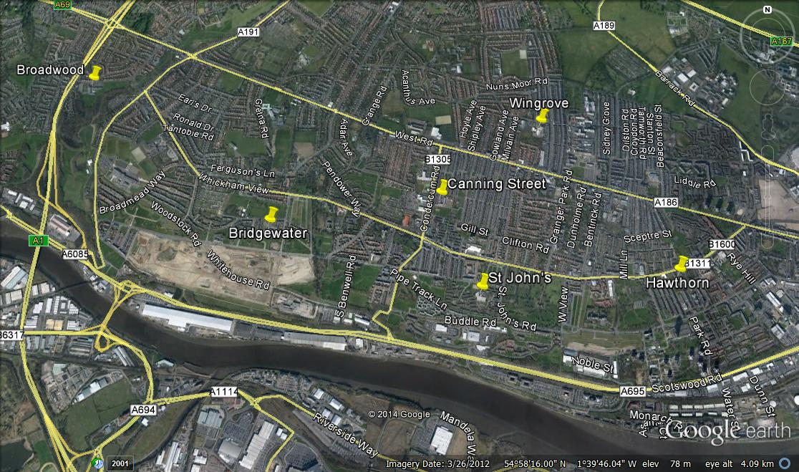

All our schools have:
- a warm and welcoming ethos;
- good and outstanding teaching and learning;
- educational achievement that is in line with or above national expectation;
- multicultural, highly inclusive and cohesive school communities.

Bridgewater Primary School
Head Teacher Sam Robson
Chair of Governors Lyn Stephenson
Deputy Head Teacher Jenn Stoker
Number on Roll Oct 2014 242 + nursery

Unique features:
- 0-3 provision open 7.30-6pm for up to 52 weeks of the year
- Early Years assessment ARC
- Judged outstanding in all areas

Mission statement: ‘Working together to improve learning for all.’

Broadwood Primary School
Head Teacher Keith Morrison

Chair of Governors Kath McIntyre
Deputy Head Teacher Susan Brooks-Tyreman
Number on Roll Oct 2014 280 + nursery

Unique features:
- Hearing Impaired Additional Resource Centre (H.I.A.R.C)
- Out of school club open from 7:30 - 8:45am and 3:00 - 5:00pm
- A positive, caring and unique ethos and atmosphere

Mission statement: ‘Our unique school...equips, empowers, inspires, values and celebrates...your unique child.’

Canning Street Primary School
Head Teacher Heather Campbell
Chair of Governors Bill Muir
Deputy Head Teacher Kathryn Herron
Number on Roll Oct 2014 412 + nursery

Unique features
- Full International School Award supported by effective and pro-active links with schools in Europe through Comenius and Erasmus partnerships
- Open plan, flexible learning environment

Mission statement/vision: 'For everyone to be a happy, resilient, confident and motivated learner who will achieve their full potential and contribute to society.'

Hawthorn Primary School
Head Teacher Judy Cowgill
Chair of Governors Anne Stoker
Deputy Head Teacher Ruth Whiteside
Number on Roll Oct 2014 210

Unique features
- In Harmony music project
- Emotional, Social and Behavioural Difficulties ARC

Mission statement: “Where every child really matters.”

St John’s Primary School
Head Teacher Tracey Caffrey
Chair of Governors Mary Nicholls
Deputy Head Teacher Daniel Nelson
Number on Roll Oct 2014 204 + nursery

Unique features
- Curriculum is delivered through Mantle of the Expert, a dramatic inquiry approach to learning.
- Opening a community sports facility in 2015

Mission statement: ‘Learning to live, living to learn.’

St Paul’s CofE Primary School
Head Teacher Judith Sword
Chair of Governors George Curry
Deputy Head Teacher Jonathan Clarke
Number on Roll Oct 2014 243 + nursery

Unique features:
- The distinctive Christian ethos

Mission statement: ‘Working towards excellence’

Wingrove Primary School
Head Teacher Jane Mullarkey
Chair of Governors Joyce McCarty
Deputy Head Teacher Trish West
Number on Roll Oct 2014 419 + nursery

Unique features
- Specialist bilingual staff who offer specific, targeted support for children with SEN and EAL
- School Community engagement opportunities
- Specialist PE team dedicated to teaching, learning and assessment of the full PE curriculum.

Mission statement: We aim to… care and share
communicate and motivate,
challenge and support.

West Trust Board

Headteacher Governor

Bridgewater Sam Robson Lynn Stephenson
Broadwood Keith Morrison Kath McIntyre
Canning Street Heather Campbell Bill Muir
Hawthorn Judy Cowgill Anne Stoker
St John’s Tracey Caffrey Mary Nicholls
St Paul’s Judith Sword George Curry
Wingrove Jane Mullarkey Joyce McCarty

West Trust Membership

Bridgewater Primary School
Broadwood Primary School
Canning Street Primary School
Hawthorn Primary School
St John’s Primary School
St Paul’s CofE Primary School
Wingrove Primary School
Newcastle City Council

West Trust Board
School Business Management
& Administration Network

Bridgewater
Broadwood
Canning Street
Hawthorn
St John’s
St Paul’s
Wingrove

WEST End Schools’ Trust Operating Structure

Trust Members (7)

The founding 7 schools are the members

Bridgewater
Broadwood
Canning St
Hawthorn
St John’s
St Paul’s
Wingrove

Partner Organisations

Organisations with which the Trust works and are inside the Trust structure

The Partnership Trust

Trust Board - Up to (24) Directors/Trustees:
Two from each school (14)
(7 headteachers and 7 governors)
One from LA
Up to 4 from other organisations

Meets for a minimum of 3 times a year

Sub-groups may be established to examine certain issues. These could contain partner member organisations as advisers.

Collaborative Organisations

Other organisations with which the Trust develops close working relationships without being inside the Trust Structure.
-Other education providers

Newcastle City Council

Partner Schools

Ashfield Nursery

Trust Sub-Groups

Established by the Trust Board for specific issues.
Head Teacher Group

Meets regularly to feed into and receive reports from the Trust

St Paul’s
Governing Body

St John’s
Governing Body

Hawthorn
Governing Body

Canning St
Governing Body

Broadwood
Governing Body
Wingrove
Governing Body

Bridgewater
Governing Body

WEST Trust Aims, Visions & Values

Vision
The Trust will take responsibility for all children and young people in our schools. By strengthening our current partnership, the Trust will improve every opportunity and enable every learner to achieve the best they can.

We will achieve this by:
- developing the Trust to provide clear, strong, effective leadership to support the schools;
- providing the highest quality teaching and learning for everyone;
- sharing and implementing examples of outstanding practice and resources;
- employing effective governance and principles of best value in the procurement and management of resources;
- rigorously monitoring and evaluating everything we do;
- working in partnership with our local community.
The key aims of our trust will impact on the lives and experiences of our children. We aim to:
- further enhance the educational experiences for every child in our care, therefore raising standards in all areas.
- raise children’s aspirations by working alongside our partners and the local community.
- share best practice across our schools, increase leadership capacity and continuing professional development opportunities, to ensure our children are provided with the highest quality educational experiences.
- strengthen and enhance the already effective relationships with parents, carers, partners and the wider community.
- retain and further promote the unique identities of our individual schools, providing our children, staff and parents and carers with a secure identity and sense of belonging.
- provide a strong local voice in response to national changes, making sure the impact on our children is always at the forefront of our beliefs.
- formalise the current partnership to protect and promote collaborative working to improve the quality of teaching and learning.
- seek opportunities for additional funding streams and financial efficiencies.
- provide our partners with the opportunity to become part of our school and local communities and to inspire a future workforce and generation.
- provide further opportunities for our local communities to flourish and ensure our children grow up to be active members of society.
- ensure every member of the Trust Board and governing bodies have a clear vision, drive and enthusiasm for positive change.
To support these aims we will establish and develop partnerships with local organisations which are mutually beneficial.

WEST Trust Key Priorities & Working Groups

Key Priorities

1. The pursuit of excellence in teaching and learning.
2. Support for and pastoral care of all pupils and their families.
3. Community projects and development.
4. Raise aspirations by identifying and the engaging partners who will bring energy and experience to enhance our learning community.
5. Robust governance, business and financial management.

Working Groups

1. The pursuit of excellence in teaching and learning.
Group Members: Heads & Deputy Heads initially, then teachers

Actions:
- Identify the priorities and the group will set up the appropriate networks.
- Deputy Head teachers to visit each school
- The group will set up meetings for school staff across the Trust to ‘get to know’ fellow Trust members. This will lead to opportunities for professional dialogue and collaboration. A timetable of events will be created.

2. Support for and Pastoral Care of All Pupils and their Families.
Group Members: Family Support Worker – Bridgewater, Parent Support Advisor – Broadwood, Family Support Advisor – Canning Street, Family Support Coordinator – Hawthorn, Parent Support Advisor – St John’s, Family Support Officer – Wingrove, Head – Ashfield, Family Support Officer – St Paul’s

Actions:
- In the first year the group will collate information regarding the services utilised across the Inner West to support pupils with particular needs and their pastoral care. The group will attempt to clarify for school support workers the myriad of professional services available; what they are entitled to and those that are most effective.
This will include health; social care and LA services. The information published will include both educational support services including guidance for specific learning difficulties and for more general emotional or behavioural support. Guidance on the services and providers may include the following (examples): attendance officers; charities; behavioural support, community services – Fire; Police; Educational Psychologists; EYFS additional support; FSO; Health Visitors; Speech and Language Specialists; Counselling; Specific Learning Difficulty Specialists; Looked After Children (LAC) Organisations and Fostering Agencies; Occupational Therapists; Parenting Partnership providers; School Health Visitors; SENTASS; Social care; Sure Start as well as independent private companies such as THRIVE.

3. Community Projects and Development
Group Members: A middle leader from each school.

Actions:
- The group will engage with staff across the Trust members to initiate greater inter-school activities. The group will publish timetables and opportunities across the school year.
- The group will explore the exchange of ideas, learning and information across the Trust through a range of media - websites for example and in pupils’ work.

4. Raise aspirations by identifying and then engaging partners who will bring energy and experience to enhance our learning community
Group Members: Steering group

Actions:
- Identify partners.
- The group will audit the current partners working within schools. They will identify successful practice and identify issues. Identified partners will be asked how they might develop their work further.

5. Robust governance, business and financial management
(Preliminary discussions identified two strands within this group –
‘governance’ and ‘business’. Within the governance group there is also the need to consider governance at two levels: the Trust and the individual schools’ governing bodies).

5a Robust Governance Group Members: A Governor from each school.

Actions:
- To form a network of governor representatives from each school to further develop the understanding of the key ‘governance’ actions within the Trust and in becoming foundation schools.
- At Trust level: Through the Board of Directors we will develop effective governor practice, procedures and structures to enable the Trust to operate successfully and add value to the work of the schools.
- At school level: We will seek to identify ways in which we can share and strengthen practice in governance including further enhancing recruitment opportunities.
- We will investigate ways of setting up effective communication between the Trust and school governing bodies.

5b Robust Business & Financial Management Group Members:
Business Managers from each school. Head from Broadwood.

Actions:
- The formation of a network of SBM/Admin working alongside the city- wide SBM/Admin network. The group will compile a skills matrix in order to audit and develop the skills base across the cluster.
- Look at how the Trust could utilise a range of digital media e.g. websites, social networking etc.

WEST Trust Business Plan 2014 – 2015

Aspects of Business Development

1. Trust Identity

2. Strategic Planning & Funding

3. Trust Operations

4. Stakeholders & Partnership

5. The Pupil Community

Aspects of  Development | Year 1 Actions (2014-2015)
Trust Identity | The WEST Prospectus will be available to all schools and partners from the day of launch. It will identify the vision, values of the Trust, key personnel, agreed operations and future operational and business plans.  This will be published for all schools and potential partners.  The WEST logo/motto will be selected for use upon all WEST documents etc. WEST stationery will be printed and utilised for all WEST business. Schools will receive WEST banners to represent membership of the Trust and assemblies will be held in schools – they will be displayed within school entrances. This will be publicised as part of the launch operation.  WEST intends to develop a website which all stakeholders can access. The website design will link all current websites across the Trust and will celebrate work by professionals and pupils alike. It will outline all of the WEST Trust work.  The WEST Trust will launch operations with a celebratory event to mark collaboration across the Trust. This event will be publicised within the press and across all schools.
Strategic  Planning & Funding | The ‘Trust Business Plan for 2015’ will be developed into a longer term, 3 year plan for the business of the  Trust.  The Trust will appoint a leader of Trust operations. The title of the role and job description will be defined.  A handbook of operations will be published to identify the roles and responsibilities of the WEST leadership. Additional key roles will be defined including the operational relationship between the board, the chair, the company secretary and the leader of operations. The handbook will also identify times and dates of meetings and events.  Administrative support for Trust business will be outlined to support the role of the operations lead and the board.  The start-up funding formulae and arrangements will be outlined and all members will contribute to the WEST Trust fund. The initial contribution for each school will be agreed and administered by the board through the work of the operational leader.  Charitable status will be explored and a plan to maximise the designation will be developed and clearly defined.
Trust  Operations | The operational work of the Priority Working Groups will continue and a ‘longer term’ plan will be  developed for each group:  1. The pursuit of excellence in teaching and learning  2. Support for and pastoral care of all pupils  3. Community projects and development  4. Engaging partners who will bring energy and experience to enhance our learning community  5. Robust governance, business and financial management  The group leads and contributors will be clearly defined as will the short and longer term aims of each group. The outcomes will be publicised across the Trust and monitored by the board through the work of the operational leader. Key professionals from across the Trust schools will be invited to join the on-going work.
Stakeholders  & Partnership | The relationship and role of formal partners will be developed and defined through liaison with individual named representatives from the partnership group. Beneficial partnership with the myriad of other agencies external to the Trust will be on-going.  Liaison with associates will continue and the contribution of associate members will be developed and monitored through the operational work. Their role will be clearly defined and developed for the benefit of the Trust. The operational lead will outline key contributions and potential benefits to liaison.  The parent group will be engaged initially through opportunities to attend Trust events for pupils but also the instigation of specific parent activity programs will be investigated and initiated.
The Pupil  Community | Pupils across the Trust will be aware that they are part of a wider formal community. Pupil launch events in school will publicise the work of the Trust and the contribution pupils can make. An official pupil launch event will be undertaken.

