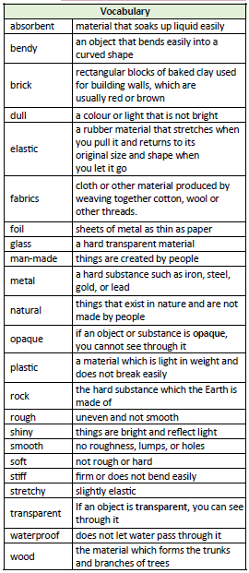

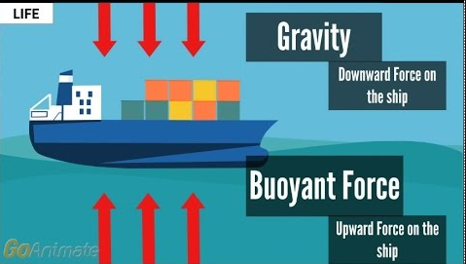
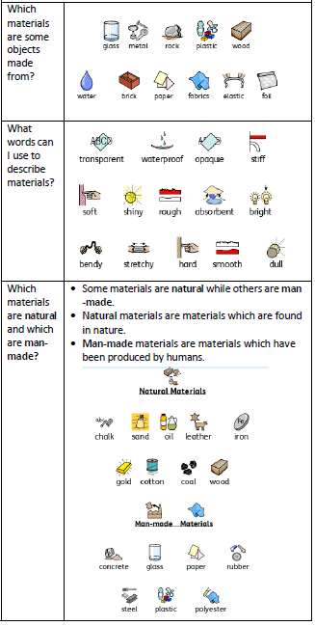

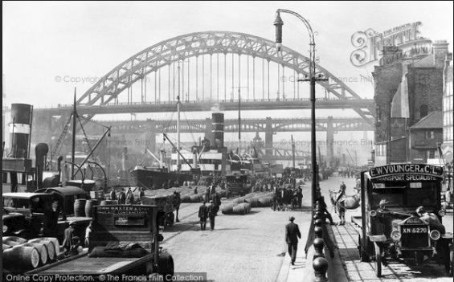
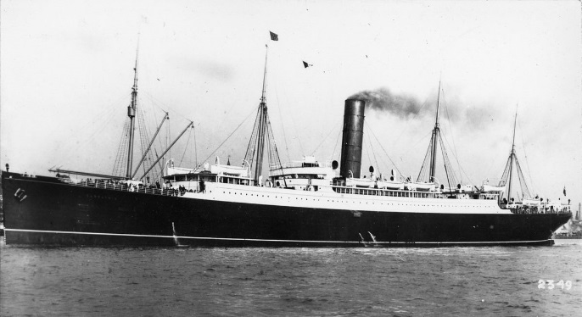
Newcastle shipbuilders
Past
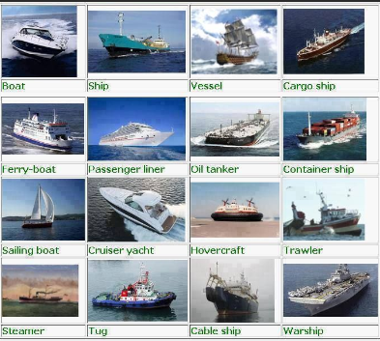
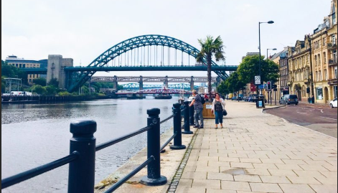
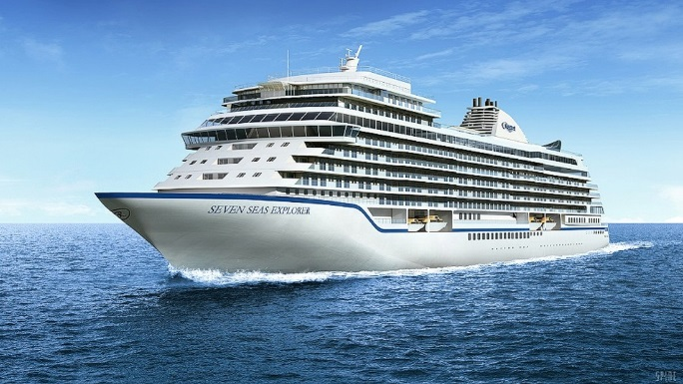
Past

Present
Present
Key Vocabulary:
Transport | How things are moved from one place to another
Vehicle | a thing used for transporting people or goods
Continent | any of the world's main continuous expanses of land
Ocean | A very large expanse of sea
Quayside | stone or metal platform lying alongside water for loading and unloading ships
Generations | all of the people born and living at about the same time
Past | The time before
Present | The time now
