**Little Pirates Starting School – Term 1a**

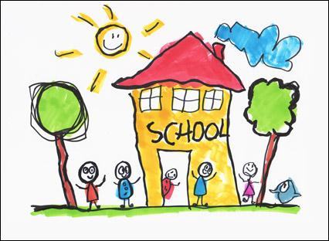

|  |  |  |  |  |
| --- | --- | --- | --- | --- |
| **Personal, Social and Emotional Development**     * Social interaction games. * Take photos of the children and share their interests. * Support children to play independently in areas of learning. * Discuss class rules. | **Key Vocabulary** | | **Physical Development** | |
| Family | Ear | | * Introduce snack time and introduce healthy eating. * Support the children to use the bathroom and to wash their hands. * Develop gross motor skills by using chalk to draw around their friends. * Explore different ways of moving and balancing. * Practice fine motor skills while playing in the Finger Gym Area.   [Related image](https://www.google.co.uk/imgres?imgurl=http://stimulatinglearning.co.uk/wp-content/uploads/2014/09/Pipe-cleaners-beads-and-co-landers-on-the-Finger-Gym-from-Rachel.jpg&imgrefurl=http://stimulatinglearning.co.uk/2014/09/gradual-admission/?doing_wp_cron%3D1558324437.0141630172729492187500&docid=GQwP7uOJs1tHMM&tbnid=kEtssV5werrZMM:&vet=1&w=800&h=491&safe=strict&bih=651&biw=1024&ved=2ahUKEwjs9IW3rLzkAhWN34UKHRxQAeYQxiAoCnoECAEQKw&iact=c&ictx=1) |
| Hair | Nose | |
| Face | Mouth | |
| Eyes | Share | |
| **Communication and Language**   * Discuss daily what the children have enjoyed about their day in nursery. * Introduce new words and vocabulary. * Play listening and attention games. * Sing action songs. * Opportunities for the children to express themselves daily. * Share stories about starting school.   C:\Program Files\Microsoft Office\Media\CntCD1\ClipArt2\j0232054.wmf [Image result for circle time early years cartoon](https://www.google.co.uk/url?sa=i&rct=j&q=&esrc=s&source=images&cd=&ved=2ahUKEwiSntfmq7zkAhVCWxoKHWmhBrAQjRx6BAgBEAQ&url=https://famly.co/blog/inspiration/10-early-years-circle-time-games/&psig=AOvVaw0jqudklQuKpqxwE82wiBrl&ust=1567863863705966) | | | | **Understanding the World**   * Share photos of their families. * Compare baby photos to how the children look now. * Explore their while handling real food in the Home Corner. |
| **Expressive Arts and Design**   * First paintings and self-portraits. * Role-play – engage the children in imaginative play based on their own experiences. * Use a variety of media to express themselves. Discuss safety while the children are using tools. |