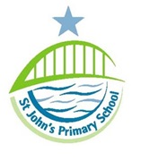
Job Vacancy at
St John’s

A vacancy has arisen for a part time evening cleaner to begin as soon as possible.
- Salary: Grade N1, £9.00 per hour

- Contract Type
Permanent, full year
- 10 Hours per Week, Mon – Thurs 3.30pm – 5.30pm

Fri 3pm – 5pm

To undertake the cleaning of designated areas, in accordance with agreed specifications and including fixtures and fittings
Ideally, the successful candidate will have experience of cleaning in a business or school environment.
This school is strongly committed to safeguarding and promoting the welfare of children and young people. The successful applicants will be required to obtain an Enhanced Disclosure from DBS and have proof of the right to work in the UK.

An application pack is available to download from the school website www.stjohns.newcastle.sch.uk/site.

Applications may be returned via email to marie.bartley@stjohns.newcastle.sch.uk

Closing date for applications is Friday 7th June 2019

